



Screen Shot 2017-06-28 at 17.28.26.png





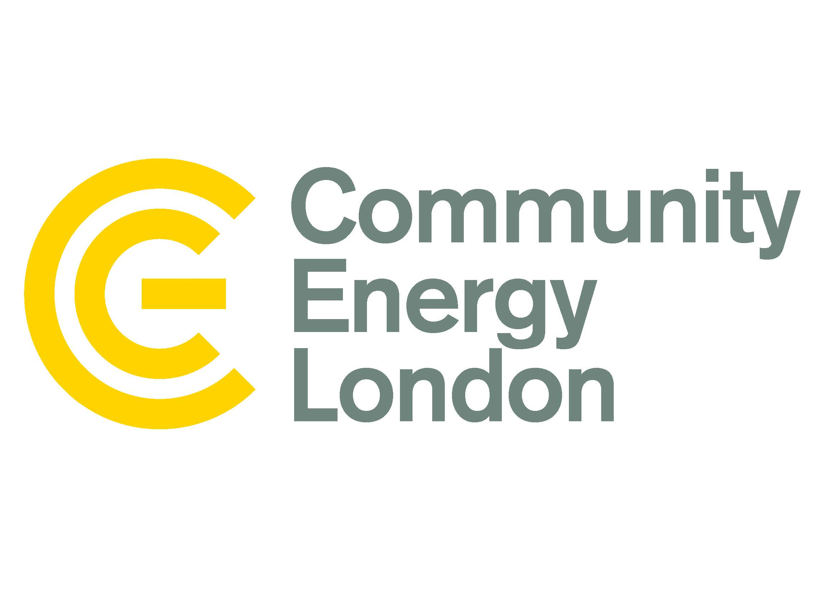





***Community Energy in a Climate Emergency:***

***West London takes action!***

**Thursday 4 July 6 – 8pm**

**#CommunityEnergy #ClimateEmergency #LDNClimateAction**

**5.45 Registration**

* 6pm Welcome **Terry Oliver, Director for Cleaner, Greener and Cultural Services,** The Royal Borough of Kensington and Chelsea (@RBKC)
* **Cllr. Cem Kemahli, Lead Member for the Environment**, The Royal Borough of Kensington and Chelsea (@RBKC @CemKemahli)
* **Dave Fuller,** Repowering London, **Community Energy in Action**: Case Study (@RepowerLondon)
* **Anca Giurgiu, Sustainability Projects Manager**, Climate Change Team, The Royal Borough of Kensington and Chelsea (@RBKC)
* **Aidan Chisholm**, North Kensington Community Energy (NKCE), **Community Energy in Action**: Case Study (@NorthKenCE @Aidan__Chisholm)
* **Grant Venner, Community Energy in Action**: Community Energy in Action: Case Study Ealing Transition and **Jo Mortensen, Sustainability Programme Manager**, London Borough of Ealing (@EalTransition )
* **Syed Ahmed, Community Energy London**, Chair Q&A session and discussion (@CommEnergyLDN @energyforlondon)

**8pm Close**

**[Refreshments will be available]**

**West London has a huge range of community groups already working to improve the environment of their neighbourhoods. Over the past few years, there have also been an increasing number of community energy projects coming forward providing advice to residents on improving energy efficiency, alleviating fuel poverty, and installing solar panels on community buildings. These projects have been designed, created and financed by the local community**

There is a real urgency for new projects to come forward, and [Community Energy London](https://www.communityenergy.london/) has worked with the Mayor of London to bring forward the [London Community Energy Fund](https://www.london.gov.uk/what-we-do/environment/energy/london-community-energy-fund), which is currently supporting over 30 projects across the capital. New London borough carbon offset funds are also emerging which are beginning to support local carbon reduction action.

The past few months has also seen close to 100 UK councils declaring a ‘Climate Emergency’. Across London seven boroughs have passed motions adopting a Climate Emergency, including in west London [Ealing Council](https://www.mylondon.news/news/west-london-news/ealing-councillors-declare-climate-emergency-16072970) and [Royal Borough of Kingston](https://moderngov.kingston.gov.uk/mgAi.aspx?ID=39969), and a petition is currently in place for a similar commitment to be made in [Hounslow](https://hounslow.greenparty.org.uk/news/petition-presentation.html)

***“Community Energy in a Climate Emergency: West London takes action!”*** will provideanopportunity to:

* Hear the latest plans from councils who are taking action on tackling climate change
* Find out how groups have developed community energy projects – from installing solar projects, to supporting energy efficiency retrofits- keeping homes warm with lowering energy bills.

**We want to share best practice, find out and support other project ideas that community groups around West London are hoping to progress and build links between groups and councils to deliver a programme of action to help contribute to London’s pathway to zero carbon.**

**Background**

The publication of the [IPCC’s 1.50c study](https://www.ipcc.ch/sr15/chapter/summary-for-policy-makers/) has spurred on the debate on climate change as never before. [School Climate Strikes](https://ukscn.org/ys4c), the emergence of [Extinction Rebellion](https://www.facebook.com/ExtinctionRebellion/) and the [Committee on Climate Change’s Net Zero 2050 study](https://www.theccc.org.uk/publication/net-zero-the-uks-contribution-to-stopping-global-warming/) has now led to the government’s pledge earlier this month to amend the 2008 Climate Change Act and legislate for a 2050 zero carbon target, the first government in the world to do this.

This year [Community Energy Fortnight (CEF)](https://hub.communityenergyengland.org/community-energy-fortnight/) (22 June to 7 July 2019) coincides with the Mayor’s first [London Climate Action Week (LCAW)](https://www.london.gov.uk/what-we-do/environment/climate-change/london-climate-action-week) – taking place 1 – 8 July 2019. This is a major new initiative by the Mayor to showcase London as global city at the forefront of tackling climate change, with the commitment, skills and expertise to achieve his target for London to be a zero carbon city by 2050.